Release 1 Strategic Analysis and Release 2 Improvement Proposal
For Sprint Review on Wednesday 14 October 2026
This pack distinguishes the current Release 1 from proposed Release 2 work. It is a review aid: every claim about Release 1 is tied to an inspectable model, form, worker or offline validation result.

1 Scope and review boundary
The strategic models show only functions that are present in the current Release 1 package. The detailed BPMN contains six executable processes: the integrated master process plus referral, appointment, finance, treatment, and enquiry/clinic-letter processes. The source package also contains Camunda Forms and seven Java external-worker job types. The diagrams below therefore describe the current increment, not the full case-study ambition.

2 Strategic BPMN model of Release 1
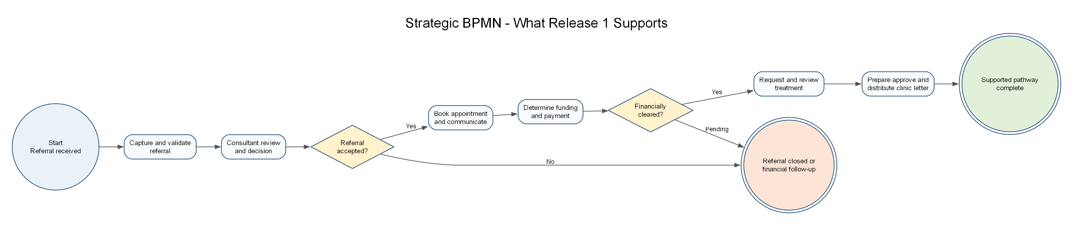
Figure 1. High-level stages supported by the current Release 1.

3 i star Strategic Dependency model
Dependency labels identify the depender, dependee and the needed goal, task or resource. “Simulated External Services” is deliberately shown as a distinct actor because the workers are demonstrations rather than production integrations.
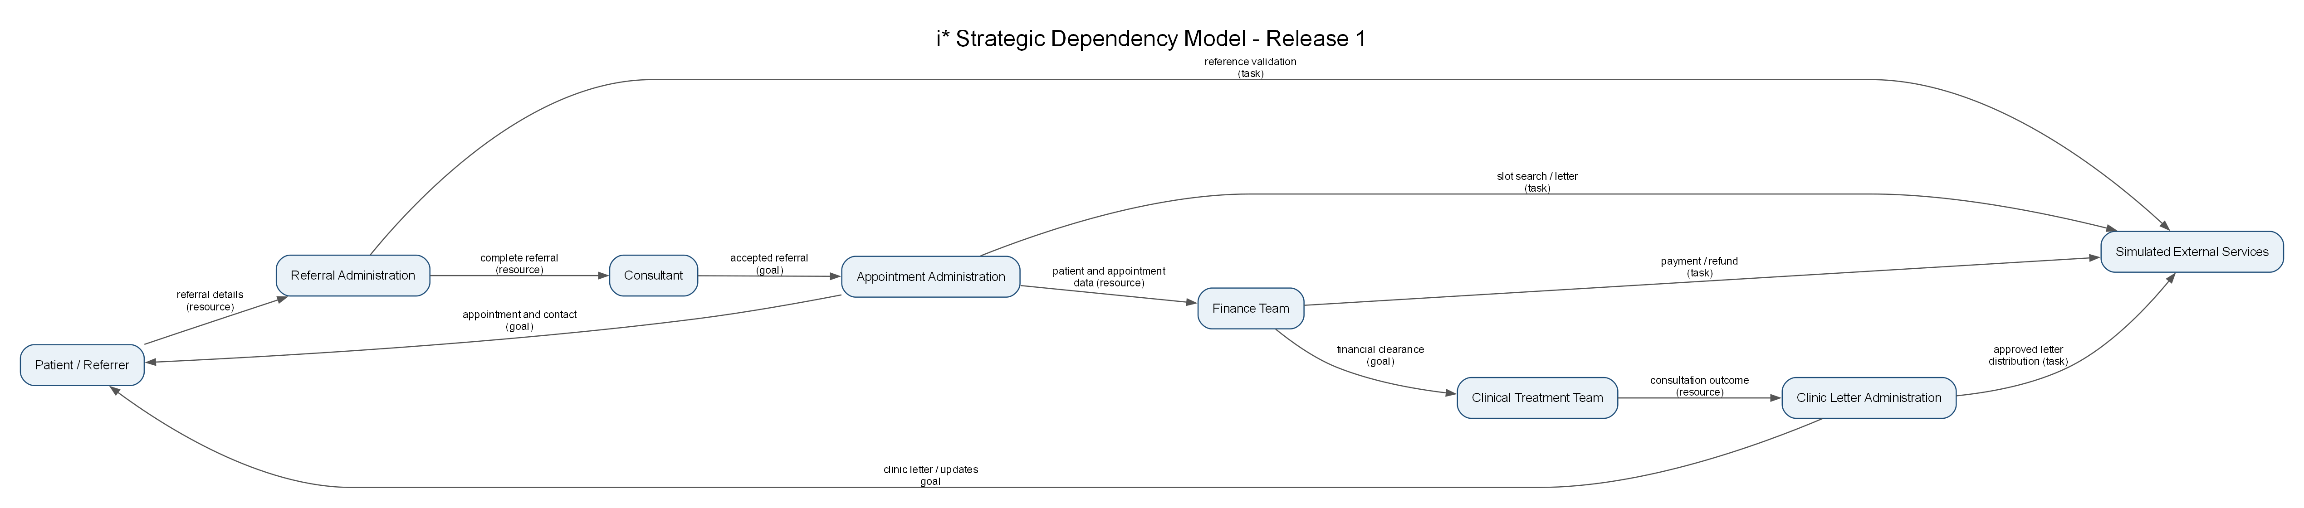
Figure 2. Release 1 actor dependencies.

4 i star Strategic Rationale model
The SR model exposes why activities are separated. Clinical decision-making remains with the consultant and clinical team; Finance controls financial clearance; administration performs coordination and communication. The softgoals make quality trade-offs visible.
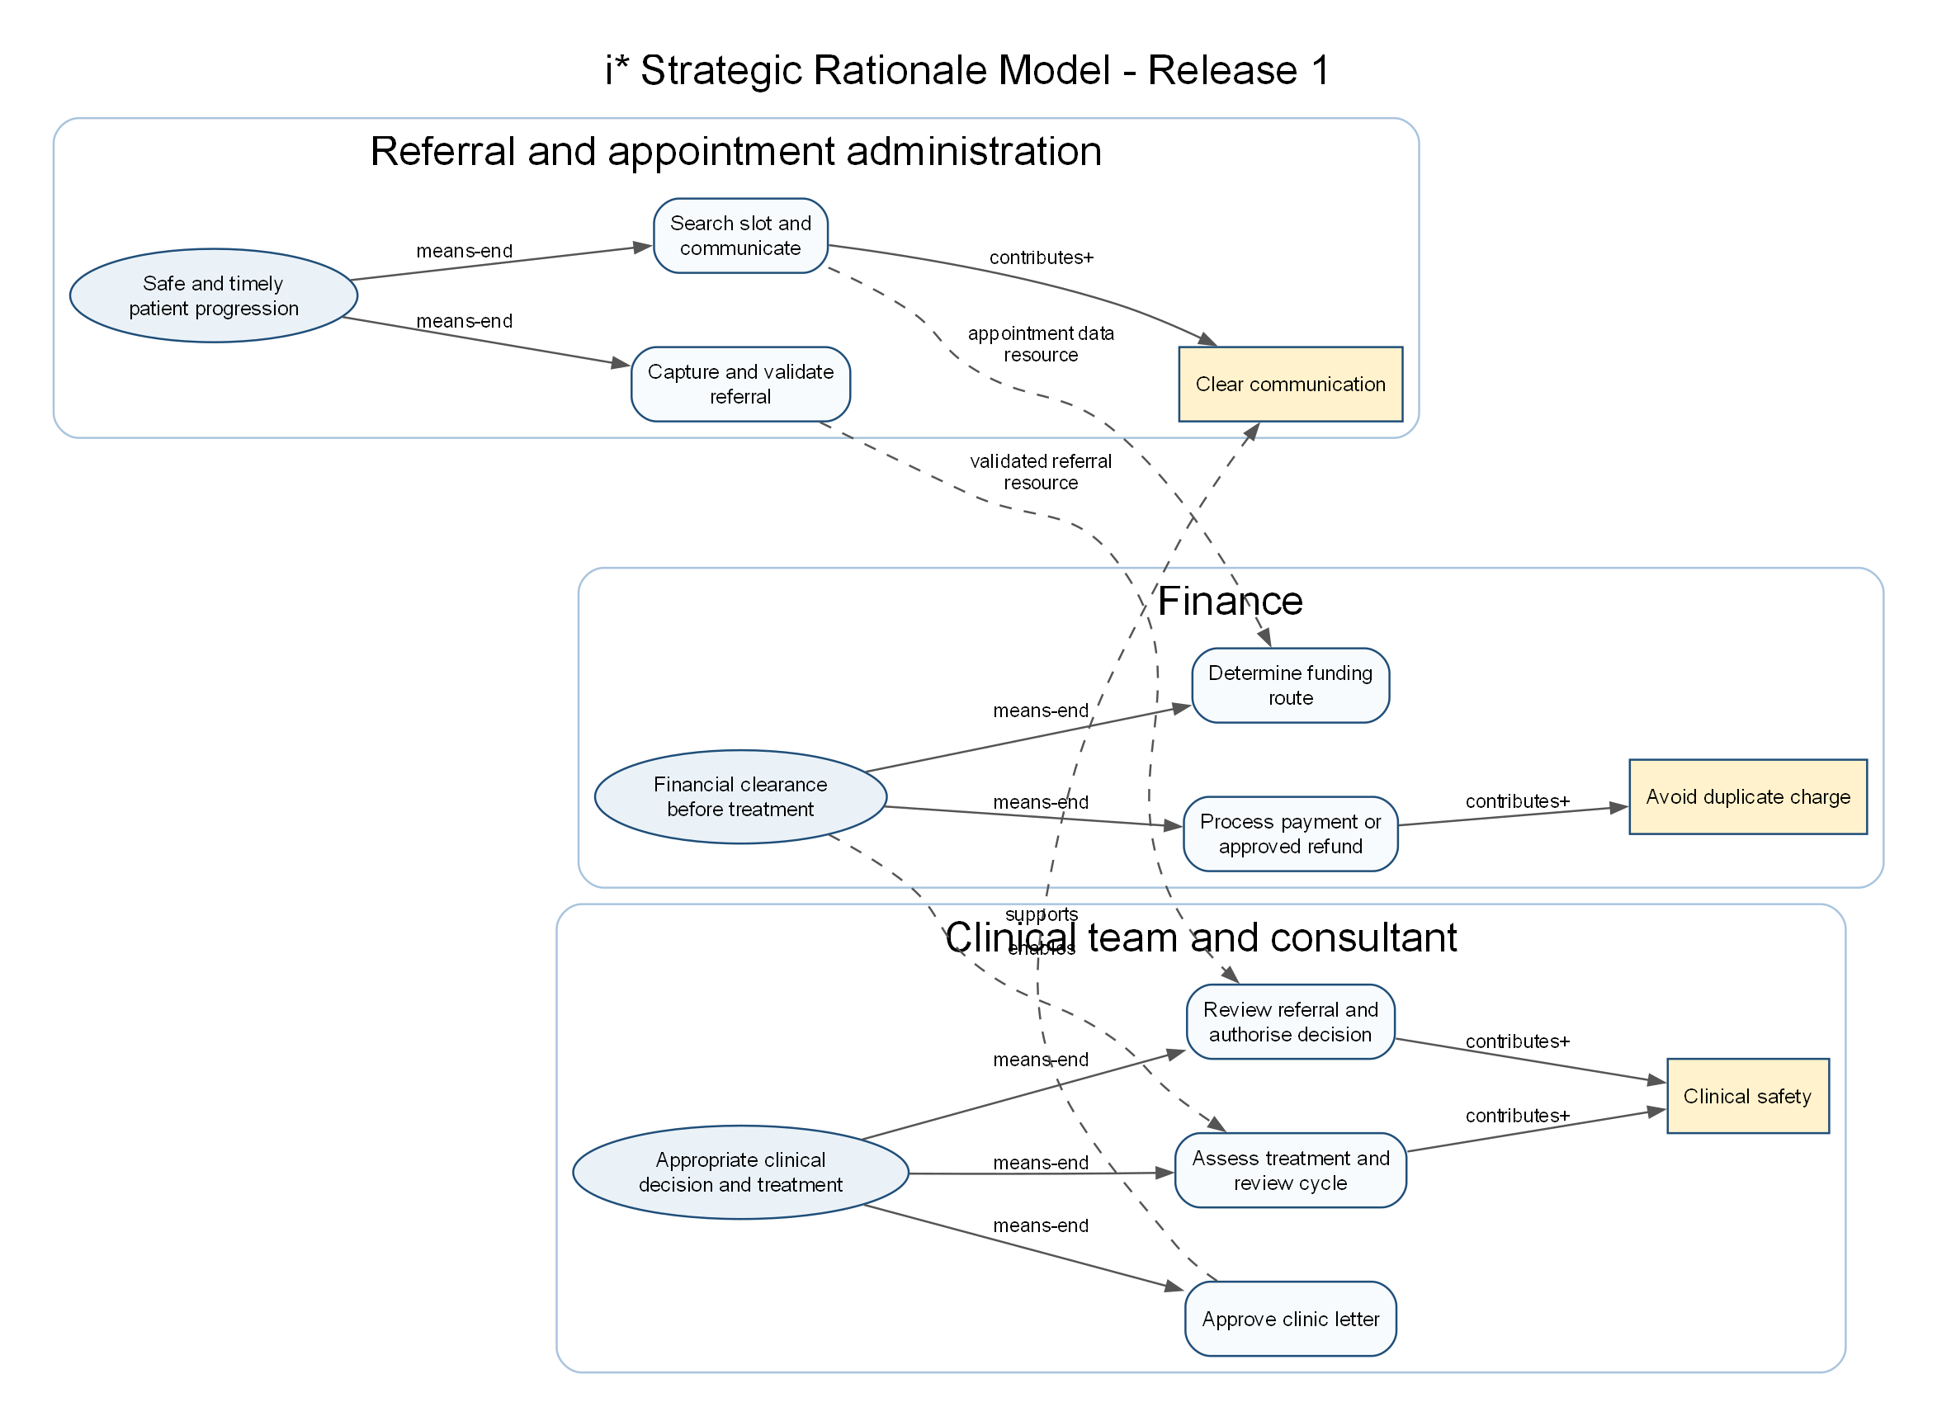
Figure 3. Goals, tasks, resources and softgoals behind Release 1.

5 Evidence-based evaluation of Release 1
Area | Release 1 evidence | Strength | Limitation or gap to validate
Referral and clinical decision | Process_Referral; referral intake and consultant-review forms; validate-referral-reference worker | Referral is validated before consultant decision and an acceptance decision gates appointment progression. | No evidence yet of a live external referral source or identity/RBAC enforcement.
Appointment and communication | Process_Appointment; booking/contact forms; scheduling and letter workers | Slot availability, two-week contact rule, no-slot and contact outcomes are modelled. | Scheduling and correspondence services are explicitly simulated; end-to-end runtime proof remains required.
Finance and safety | Process_Finance; payment/refund workers; five added finance outcome forms | Payment status branches include confirmation loss and duplicate-risk investigation; refund is approval-gated. | No persistent audit store or verified payment-provider integration is in this release.
Treatment | Process_Treatment; consent/request/cycle forms; resource worker | Human clinical judgement and resource availability are separated from automation. | Treatment authorisation is captured as workflow data; stronger role-based authorisation needs a Release 2 design.
Clinic letters and monitoring | Process_EnquiryLetter; approval/monitoring forms; letter worker | Clinical approval occurs before distribution and monitoring paths are represented. | Timed reminders/escalations need broker runtime demonstration, and delivery is simulated.
Configuration consistency | Offline validator: 6 BPMN, 19 Forms, 7 job types | XML/JSON, form bindings, call targets and worker job-type references passed offline validation. | Static success is not the same as a deployed Camunda execution.

6 Proposed Release 2 improvements
Priority | Improvement action | Reason from V1 evaluation | Acceptance evidence
P1 | Run normal and exception journeys in the teaching Camunda environment and retain task/worker evidence. | Current validation is structural; a broker execution is still required. | Deployment version, completed task screenshots/logs, worker output and result for one normal and one exception case.
P1 | Add RBAC and a durable audit trail design for consultant, clinician and finance approvals. | V1 models responsibility but does not prove authenticated authorisation or audit persistence. | Role matrix, access design, audit fields and an approval-rejection test.
P1 | Replace simulated integration boundaries with adapter contracts and failure/retry policy. | Workers identify themselves as simulated external services. | API contract stubs, timeout/error mapping and non-production-data statement.
P2 | Strengthen form accessibility with help text, error-message review, keyboard-only check and language/support preference. | Labels and required checks exist; user-centred testing is not yet evidenced. | Accessibility checklist and observed user-task test results.
P2 | Make monitoring time-based and measurable. | The BPMN includes monitoring paths, but timers and operational measures require demonstrated configuration. | Timer configuration, reminder/escalation evidence and a monitored-age test.

7 Requirements traceability snapshot
Requirement | V1 status | Evidence | V2 next step
Executable operational workflow | Supported | Six BPMN files are executable; master uses called processes. | Deploy in agreed order and capture runtime evidence.
Forms with validation and bindings | Supported | Nineteen JSON forms; validator resolves all BPMN form IDs. | Run accessibility and variable-persistence tests.
External worker integration and failure handling | Partly supported | Seven job types; payment and letter workers have guarded outcomes. | Demonstrate broker failures/retries and real-service adapter boundary.
Authorised clinical/finance decisions | Partly supported | Named lanes, approval tasks and newly bound audit forms. | Implement role enforcement and durable audit record.
Operational monitoring and assurance | Partly supported | Clinic-letter monitoring paths and status variables exist. | Demonstrate timer execution and reporting.

8 Review conclusion
Release 1 is a coherent, inspectable operational baseline: it covers the main referral-to-treatment pathway and includes meaningful safety branches. The largest risks are not diagram gaps but evidence gaps: runtime deployment, role enforcement, accessibility testing and replacing simulated external services. Release 2 should prioritise those evidence-backed improvements before adding new scope.

9 Runtime rehearsal evidence to capture
Evidence item | Normal journey | Exception journey
Deployment record | Model deployment/version and start variables | Same deployment version recorded
Form evidence | Completed task with submitted variables | Validation or corrected-input task
Worker evidence | Completed job type and returned variables | Failure or controlled alternative output
Process result | Master pathway completion | Named recovery, pending or escalation route
Team explanation | Owner explains data and gateway | Owner explains risk and safe recovery

Keep this evidence with the relevant owner. If the teaching environment is unavailable, say exactly that and show the static validation result instead of claiming an execution that did not occur.
Editable sources supplied with this pack: Strategic_Process_Model_V1.bpmn and the three DOT source files in iStar_Source. SVG exports are available for insertion into slides or documentation.

